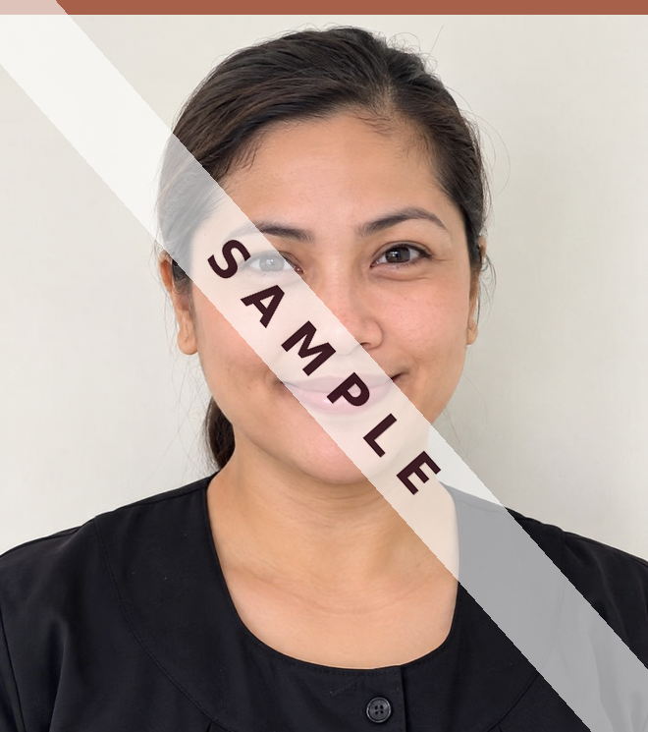  Please include a clear, recent photo here. | ANNA M. RIVERA  37-25 75th Street, Apt. 1-A, Jackson Heights, NY 11372  Cell Phone: (917) 555-0147 · Email: anna.rivera@example.com  Seeking: Live-In / Live-Out · Full-Time Nanny / Light Housekeeping · Available March 2027
EDUCATION & TRAINING
Queensborough Community College Bayside, Queens, NY 2013 – 2015
Associate of Arts, Early Childhood Education
Newborn Care / Baby Nurse Certificate New York, NY 2019
Certificate of Completion
Infant & Child First Aid and CPR New York, NY Renewed 2026
American Red Cross · Current through 2028
QUALIFICATIONS
- 9 years of full-time household experience with families in New York City and Westchester County
- Newborn, infant, toddler, and school-age care, including twins
- Light housekeeping, family laundry, meal preparation, and grocery shopping
- School runs, activity schedules, appointments, and household errands
- Fluent in English and Spanish · Comfortable in homes with pets · Confident swimmer
- Optional: Valid New York State driver's license; comfortable driving in the city and suburbs
HOUSEHOLD EXPERIENCE
Each position below lists the employer's contact information, work schedule, and reason for leaving.
Hartley Family Upper East Side, Manhattan, NY June 2021 – Present
Full-Time Nanny / Family Assistant · Live-out · Monday–Friday, 8:00 a.m. – 6:00 p.m. · Children ages 2 and 5 at hire
Sole charge of two children while both parents worked. Managed the daily routine, meals, naps, and bedtime. Walked the older child to and from school and coordinated after-school activities and pediatric appointments. Handled children's laundry, tidied play and bedroom areas, and kept the grocery list. Traveled with the family to their summer home in Amagansett each August.
Reference: Mrs. Claire Hartley, (212) 555-0162 · Reason for leaving: Both children start full-day school in September 2027

Whitmore Family Scarsdale, Westchester County, NY March 2019 – May 2021
Full-Time Nanny · Live-out · Monday–Friday, 7:30 a.m. – 6:30 p.m. · Newborn twins at hire
Full charge of newborn twins from six weeks of age. Established feeding and sleep schedules, kept daily bottle and nap logs for the parents, sterilized equipment, and managed nursery organization and supplies. Handled all infant laundry and drove the children to appointments and early play programs in the family's vehicle.
Reference: Mrs. Diane Whitmore, (914) 555-0138 · Reason for leaving: Family relocated to Boston

Caldwell Family Brooklyn Heights, Brooklyn, NY August 2017 – February 2019
Nanny / Housekeeper · Live-out · Tuesday–Saturday, 9:00 a.m. – 5:00 p.m. · Child age 4 at hire
Cared for one school-age child with light housekeeping duties. Managed the school run, homework support, and after-school activities. Prepared family dinners four nights a week, handled weekly grocery shopping, laundry, ironing, and general cleaning of a three-bedroom apartment. Cared for the family's two dogs.
Reference: Mr. Peter Caldwell, (718) 555-0119 · Reason for leaving: Sought full-time position with earlier weekday hours
ADDITIONAL EXPERIENCE
Little Harbor Day School Long Island City, Queens, NY September 2015 – July 2017
Assistant Teacher, Toddler Room · Full-time
Supported the lead teacher in a classroom of twelve children aged two to three. Led small-group activities and communicated daily with parents.
Recommendation letters: Copies from the Hartley family and the Whitmore family are attached to this resume.

